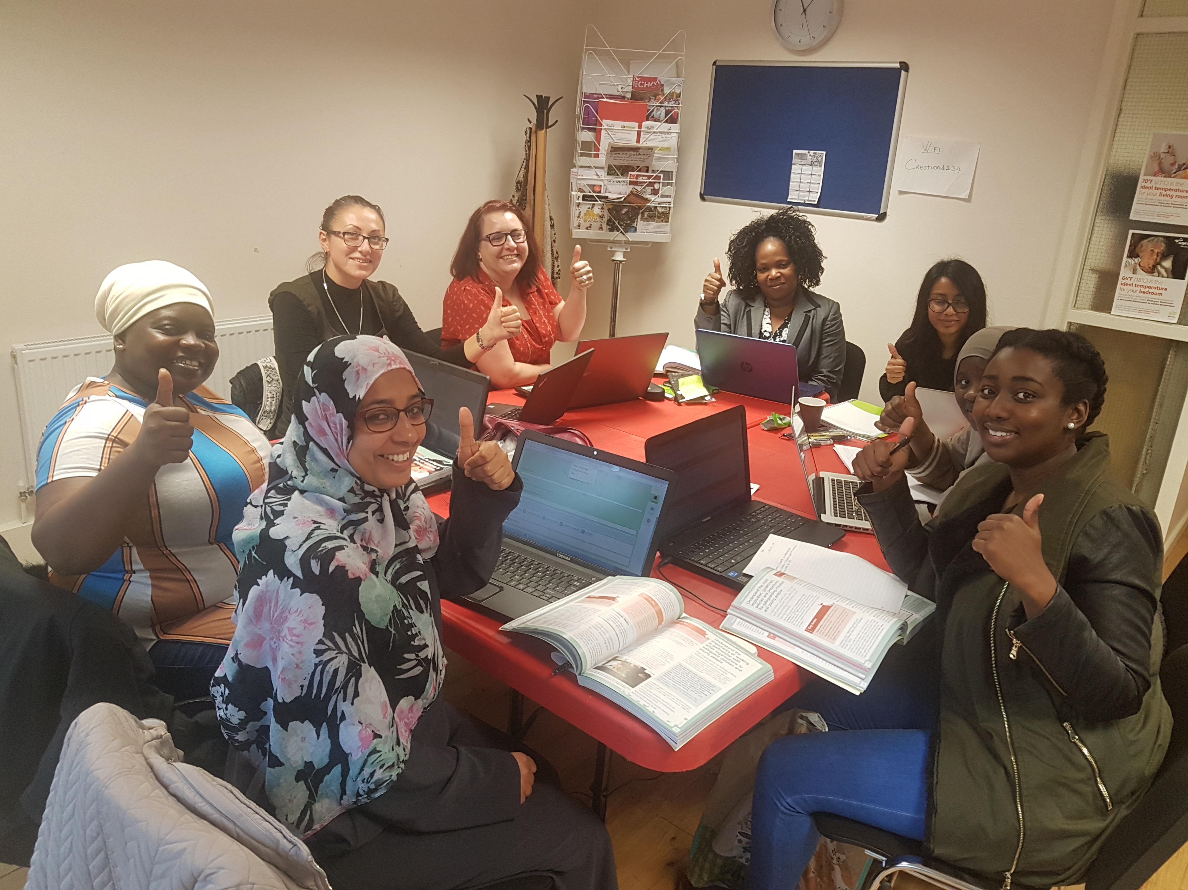
EVALUATION AND PLANNING REPORT
SE17Working
2012 - 2018
Creation Trust  Email: info@creationtrust.org  Website: [Website Here] | Tel: 02077038923 / 02077084088  Address: The Cabin 1 Beaconsfield Road SE17 2EN | 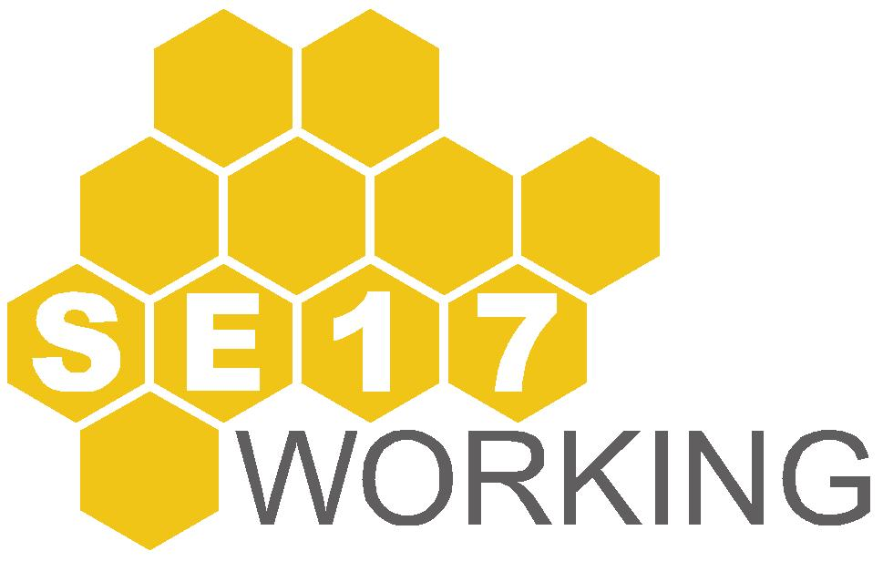
TABLE OF CONTENTS
INTRODUCTION 3
Aylesbury Tackling Worklessness Together (ATWT) 5
SE17Working 7
PROGRAMME HIGHLIGHTS 10
Pop Up Shop 10
Black Male Forum 11
Work Out Well! (WOW) 12
In-Stall Project 13
Aylesbury Apprentice 16
Vlogging Project 17
FUNDED PROJECTS 18
Kaleidoscope 18
Cambridge House 18
Robust Training 19
Inspire 20
Certitude 20
Elm House Training 21
TARGETED DELIVERY 23
Construction 23
ESOL 25
OUTCOMES 26
THE FUTURE 28
Proposed Delivery 28
FINANCIAL HIGHLIGHTS 2017-2018 30

Introduction

The Aylesbury New Deal for communities (ANDC), a government funded scheme, operated on the Aylesbury Estate from 2000 - 2010. Their remit was to work with the council to redevelop the Aylesbury Estate & improve the lives of residents. They did this through physical improvements to the area, as well as providing social and economic opportunities to improve the lives of the residents. These projects included supporting programmes that tackled high levels of unemployment.

In September 2005, the London Borough of Southwark took the decision to demolish all of the existing blocks on the Aylesbury Estate and replace them with high quality new homes. The redevelopment scheme was to take place over a 15 year period, seeing investment in the area of circa £1 billion, and to also include the creation of a new community, social, health and education infrastructure. The Aylesbury Area Action Plan (AAAP) cemented the future role and function of the area with detailed plans for its buildings and land, community infrastructure, economic, and social policy.

Work has been completed on sites 1a and site 7, with L&Q Housing Association (L&Q) delivering just under 500 mixed tenure homes. In 2014, Notting Hill Housing Trust were awarded the contract to complete the phased redevelopment of the rest of the estate. By 2028, in the region of 4,600 mixed tenure new homes will have been delivered.

In its final year, the NDC programme worked with residents, Government, the London Borough of Southwark (LBS) and other key agencies to ensure that the social and economic improvements made through the NDC interventions were sustained and the challenges that remain are tackled with work continuing either through mainstreaming, other future partnership arrangements, or through the NDC successor vehicle, The Creation Trust.

Creation Trust, a registered charity, was established in 2007 as a part of the succession strategy for the NDC programme. The succession strategy was designed to identify ongoing needs of residents, and the development of solutions to meet those needs. This has been achieved through a combination of sustaining local interventions that proved to be successful, and whilst the Trust was not required to carry out all the work that the NDC programme covered, it was tasked with responding where a need is demonstrated within the sphere of community capacity building, local social and economic development and increasing opportunities for residents to reach their potential.

  - Creation operated for 3 years under the auspices of the ANDC. In 2010, the official end of programme saw Tribal Consulting, the management company tasked with running the ANDC programme, leave the estate and hand over all projects to Creation.

  - Creation Trust celebrated its 10th year anniversary in 2017. The organisation has doubled its turnover since inception; employs 7 key members of staff; and holds the lease on several properties. Creation’s work is now focused on supporting residents, especially the most vulnerable residents, through the regeneration process; working with young people; and delivering an employment programme that meets the needs of local people.

aylesbury tackling worklessness together (atwt) TO SE17WORKING

In 2010 Creation inherited a 3 year commitment to fund Aylesbury Information Advice and Guidance (AIAG) work from one provider operating from the Aylesbury Learning Centre, based in Wendover.

Project Rationale

  - Worklessness was a key agenda throughout the lifetime of the ANDC programme. A worklessness focus group was developed to carry forward key elements of previous projects (namely the AIAG, Multiskills and Social Enterprise Development projects) to provide a direct and targeted range of project support to the local community. The project was tasked with driving down worklessness, through engaging and working with the ‘hardest-to-help’ workless groups in the area, whom face the greatest barriers in finding work.

  - The project was funded to provide support and staffing for the development of a partnership approach to tackling Worklessness for residents of the Aylesbury Estate. Due to the high number of unemployed in comparison to the Borough average, it was imperative to ensure that clear and up to date information was sent to residents giving them the best opportunity to move into employment.

  - The Aylesbury Tackling Worklessness Together group (ATWT) was thus set up to provide a pro-active outreach approach to:
- engage with workless residents to encourage them to access the many existing support services
- closer partnership working and ease of referral by defining working relationships between key agencies / partners through a charter agreement setting out respective rights and responsibilities
- support personalised responses to the needs of the most disadvantaged households in the area, providing customised, intensive and long term help
- add value to existing provision from statutory providers, and be supported by reaction in circumstances where these agencies and providers are restricted from doing so themselves.

  - ATWT activities included co-ordinated Employer Engagement and workshops for tackling immediate barriers to work such as Motivation; CV/application writing; and interview skills, thus ensuring that residents are job ready and have an understanding of what is expected of people in the work place. The project was set a target of 80 jobs outcomes over the calendar year.

Delivery Approach

2.5 Creation was tied into delivery through the ATWT organisations that had secured 3 years funding at the end of the ANDC. The providers were tasked with:

- Supporting local adults aged 19 plus into training, work and career progression through a range of client-centred services delivered from the Aylesbury IAG Job suite in the Aylesbury Learning Centre.
- This also includes job brokerage (placing people into employment), providing work experience placements and providing English for Speakers of Other Languages (ESOL) courses.
- Social Enterprise - helping local residents set up social enterprises, engaging and developing their ideas and providing on-going support

2.6 Creation funded this project with support from the London Borough Southwark (LBS), Refugee Access to Employment/Multiskills and Aylesbury Information Advice and Guidance (formerly known as Career Outreach and Counselling).

Funding

2.7 The overall cost of the project was estimated to be £69,250 per annum, based upon past expenditure profiles and prioritisation of the key/core elements of individual projects.

2.8 The ATWP was anticipated to attract and secure additional/match funding, with 50% of the funding sought from external funding sources in years 1 and 2, increasing to 75% from year 3 onwards. The assumed rising contribution over the first 3 years was based upon Creation’s belief that more funding will be forthcoming and easier to secure when providers had established a track record of delivering against a worklessness theme.

2.9 In 2011 the unemployment rate (Job Seekers Allowance claimants) on the Aylesbury Estate had dropped significantly during the course of the NDC programme, along with the worklessness rate which had seen a drop from 41% to 33% in 2008. However by 2012 NOMIS records began to show that that unemployment in the Michael Faraday Ward rate was higher than the borough Average. With the 3 year funding commitment reaching the end, Creation was in a position to review how it moved forward with support for employment programmes.

- SE17WORKING

Review & Mapping

The then estate based worklessness project, funded through Creation Trust, was run by Al Pafeno. The information gleaned from the monitoring of this Project was unable to verify the impact of the work delivered. Creation’s board took the strategic decision that with direct delivery, earmarked funds could be better used to target services for Aylesbury Estate Residents rather than a third party organisation which may have a wider geographical remit and commitment to other funders.

In June 2012 EmploySE17 was formed as the successor to the former ATWT Partnership, however due to the name being similar to EmploySE1, a neighbouring Borough and Bankside employment initiative, the partnership was renamed SE17Working. Membership consisted of former members of the ATWT and organisations identified through a mapping exercise of local employability training providers. The remit of SE17Working was to help Aylesbury Estate residents find employment by removing any barriers that are keeping residents from finding work and linking them to employers.

Creation Trust key activity areas for 2012/13 were as follows:

Delivering youth programmes to increase educational attainment, improve well-being and reduce anti-social behaviour

Supporting vulnerable residents who are isolated and at risk with a focus on depression and anxiety for all ages & advocating for them

Delivering services for adults to improve their skills, economic opportunities and well-being

Providing residents with opportunities and information to encourage them to participate in their local community

Representing residents on relevant decision-making forums in order that their voice is heard especially in relation to housing and regeneration issues

Campaigning to improve the local community through supporting effective regeneration, working to reduce crime, lobbying for community facilities/services and housing standards

The SE17Working Worklessness Programme compliments key activity areas 1, 2, 3 and 4 through the development of a bespoke welfare to work programme. All projects were to be delivered with one or more of the partnership organisations as identified in the Mapping Exercise. The programme included the direct employment of staff who would deliver workshops, one to one support, information and guidance and commission specialist/themed projects.

3.5 In April 2012 the members of the ATWT were advised that all funds attributed to the former ANDC had been accounted for, and to this end all Aylesbury Estate worklessness activities funded through these monies had ceased. They were also informed that Creation Trust had introduced the SE17Working Worklessness Programme as a local body to provide a mechanism for Creation Trust to identify worklessness priorities with specific aims, objectives and targets. A new Steering group was created to benefit the former members, as well as new, as identified through funder commitments, Government policy and Labour Market trends.

Mapping Exercise Providers

3.6 The mapping exercise of local employability training providers focused on those that had services continuing or starting after 1st April 2012 which were targeted at Aylesbury Estate residents. Efforts were concentrated on identifying organisations using the following criteria: those funded through Southwark works; those formerly funded through Creation Trust; and those who had either made direct contact with/or worked in partnership with Creation in 2011- 2012.

3.7 After initial discussions with those identified, it was apparent that they had not been able to infiltrate the Aylesbury Estate in terms of working with residents as much as they had both expected or hoped to. Expectations were of differing levels from the number of clients they could interact with, to the readiness and skills set of referrals. An absence of provider co-ordination on the Aylesbury Estate was also noted with providers working with the same clients/client groups.

3.8 29 providers were identified in this exercise.

A4E
- Apex Trust
- Aylesbury Learning Centre
- Southwark Muslim Womens’ Association
- 50+ Employment Link
- The Camden Society
- Family Mosaic
- Hilcroft
- Inspire
- Ingeous
- Lifeskills Solutions
- London Bubble
- Pecan
- Red Kite Learning
- REED in Partnership
- Robust Training
- Roots and Shoots
- Southwark Works
- Southwark Adult Learning
- Southwark Children’s Services
- Young Southwark works
- Start Jobs
- TBG Learning
- Tomorrows People
- Toucan Employment Volunteer Centre

3.9 In 2018 we carried out a similar exercise using the same criteria. 22 providers were identified as follows:

- 2nd Chance
- Advising communities
- Age UK
- Aim Apprenticeships
- Big Local Works
- Cambridge House
- Catch 22
- Cherrytree Foundation
- Gingerbread
- Go Train
- Inspire
- Ixion
- L&Q
- Maximus/Remploy
- National Careers Service
- Notting Hill Genesis
- Pecan
- Peabody
- People Plus (formerly A4E)
- REED In Partnership
- School of Social Entrepreneurs (SSE)
- Southwark Works
- Street League

It is interesting to see which organisations remain engaged with clients; those new to the area; and those whom have not managed to continue running projects – mainly due to funding cuts and/or a change in their funding criteria.

4 PROGRAMME HIGHLIGHTS
Pop Up Shop

Between 2012 and 2015, SE17Working delivered a Pop-up-Shop project based at 55 East Street, SE17. The shop was acquired through negotiations with Peabody Trust who offered the shop space for free with Creation responsible for the electricity and rates.

4.2 As a result of this project 38 clients went on to positive outcomes, and 21 business plans were completed. This project added value to the worklessness programme through the introduction of Client Files which included the design and use of registration and consent forms, and individual client action plans which are integral to worklessness programme delivery in terms of identifying need and capturing the clients growth and journey into work. The Pop-up-Shop also provided a means for clients to gain valuable work experience and entrepreneurial skills.

Of the 21 business plans completed, 1/3 businesses are continuing to trade.

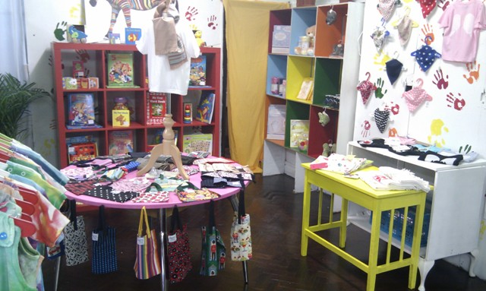

Participating in Pop up Shop projects has provided residents with real, ‘hands on’ work and customer service experiences, and has proven to prepare them for employment. Those who have not started their own business have chosen to enter into employment.

Total

Black Male Forum
4.3 In May 2012 a news article in The Evening Standard stated that, according to official Government statistics, 55% of British black males aged 16-24 were unemployed. Previously in February 2012 the Southwark on-flow unemployment rate for 18-24 year olds showed an increase of 2.5% within one month which lead officials to conclude that black male unemployment may be on the rise. This provoked some conversation amongst national and local voluntary groups working with this particular target group, in most part positive, alongside some rather stereotypical and negative views.

4.4 In response to this issue, and keen to hear what this target group actually felt themselves, SE17Working held a forum for young Black Minority Ethnic (BME) male Aylesbury residents Aged 16-24, in collaboration with the Black Training and Enterprise Group and Job Centre Plus, with the aim to ensure that their voices were heard to assist in planning and developing appropriate work related and support events which they would find useful, interesting, and relevant. The session consisted of a “question time” workshop where they would be able to put questions to a panel together with interactive break-out sessions. The Forum was held in collaboration with the Black Training and Enterprise Group and Job Centre Plus.

4.5 The Forum aimed to establish whether or not to create a “stand alone” employment project for young BME males or to integrate them into the existing SE17Working projects and services which is typically non-specific in terms of the ethnicity and ages of clients supported.

4.6 As a result of the event we managed to engage with 10 young men from this group with 3 going on to the Pop up Shop project, and the remaining 7 supported through the SE17Working Worklessness Programme. These interactions resulted in 5 finding employment and 4 going into further training and Education.

4.7 Since 2014 SE17Working has secured a total of 105 job outcomes for young BME males aged 16-25. In addition to CV writing and courses to develop soft skills such as confidence, motivation and interview skills, we have supported young people with applying for CSCS cards and SIA licences.

  - The unemployment rate for BME males aged 16-25 was 15% at the end of 2017 compared to 44% in 2012. This might be due to a number of BME focused work schemes through various partners and work programme providers to support BME males aged who fall into other criteria which unfortunately are endemic to this target group such as homelessness, ex-offending, and mental health. We have also engaged with a high number of young BME males who do not claim benefits.

4.9 SE17Working continues to address the issue of youth unemployment for both BME males, as well as 16-25 year olds in general who are not in employment, education or training through recruitment onto the SE17Working Skilled It! project. This project facilitates networking events where young people are supported to attend a job interview; take up apprenticeships and learn new skills. Estate based events are also held where young people can meet our partners and in doing so are made aware of what additional support services are on offer to them in the surrounding area.

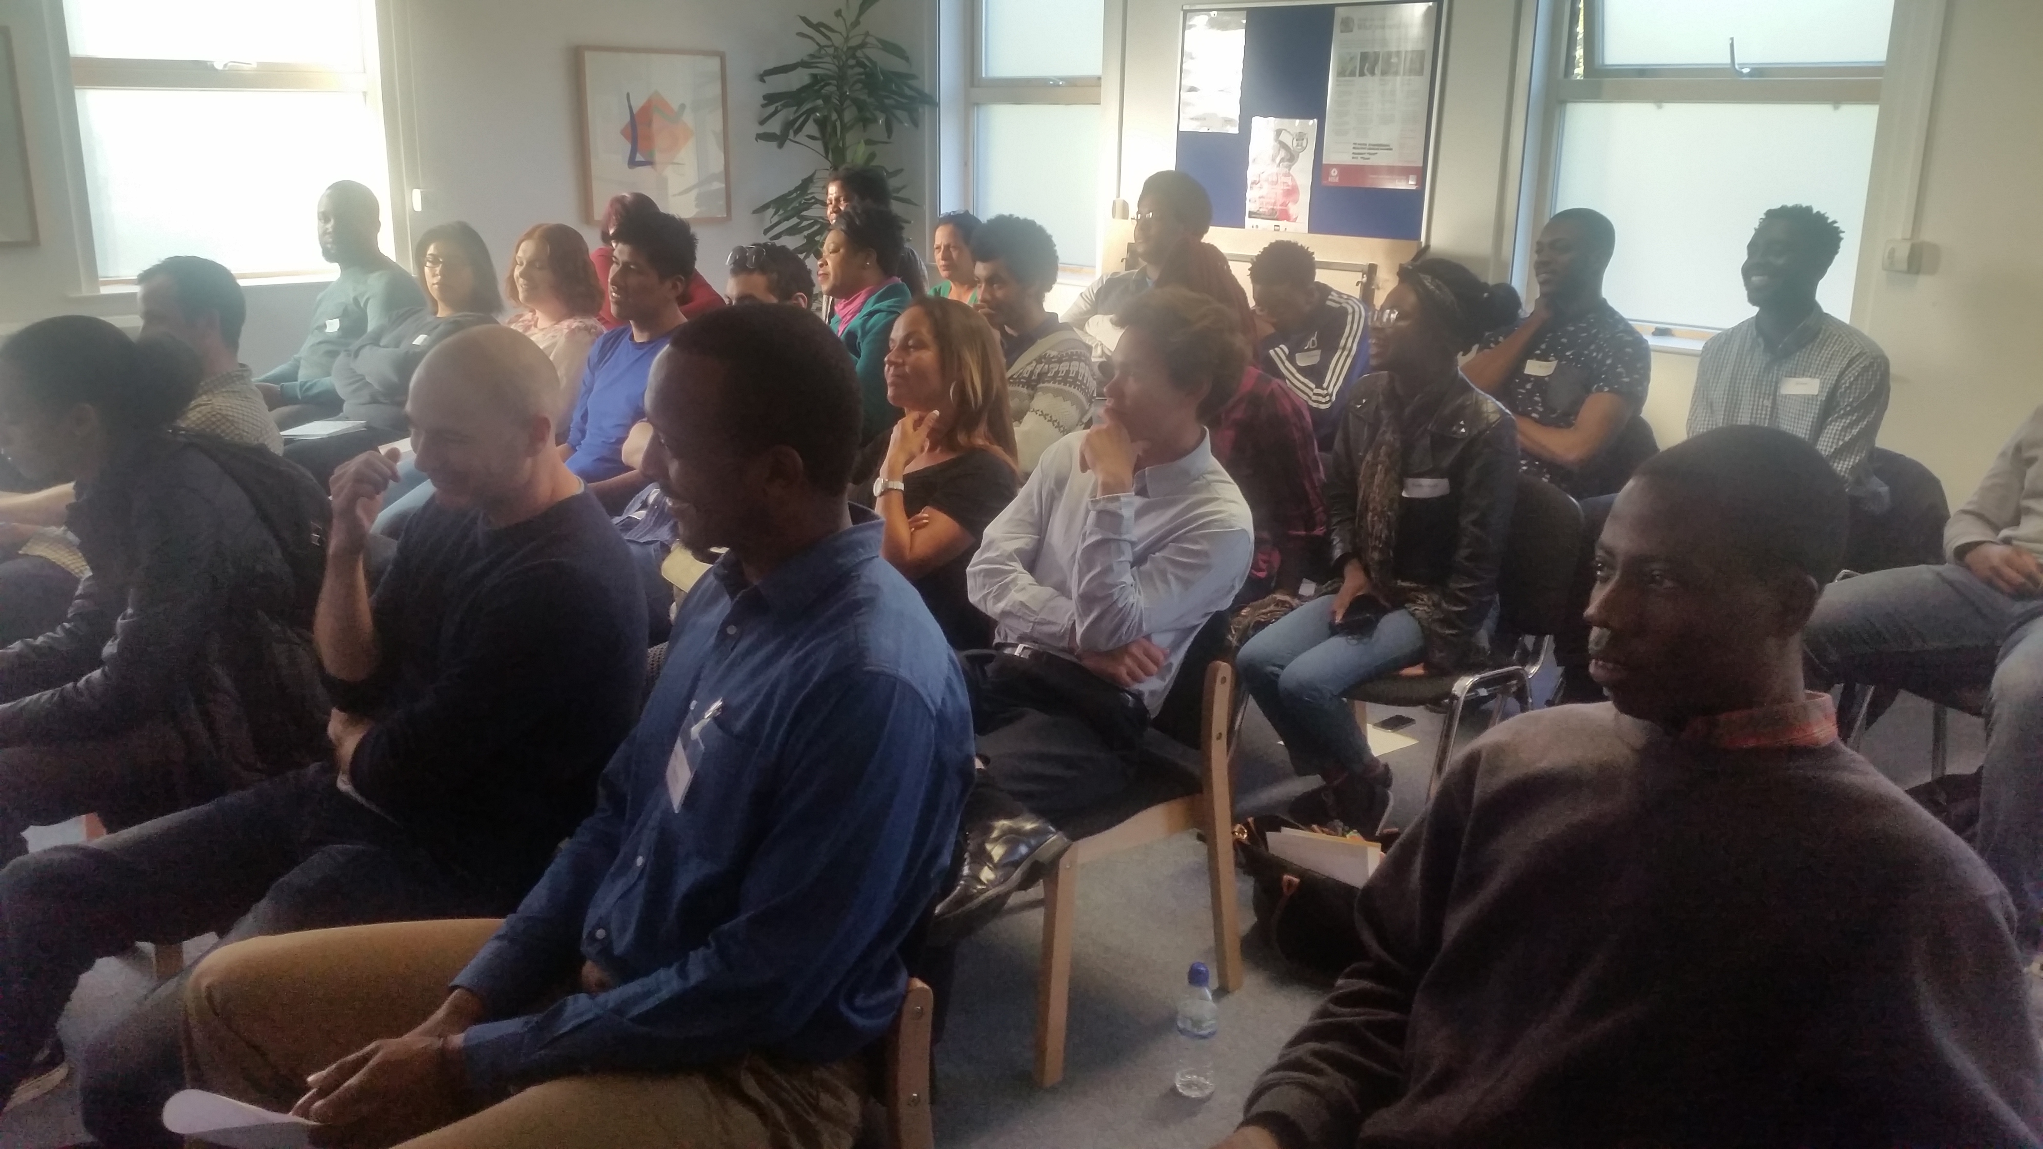

The SE17Working Programme has helped to find employment for 136 young people with a conversion rate of 53%. This is the highest conversion rate – from support into employment -amongst all SE17Working target groups.

Total

Work Out Well! (WOW)
4.10 The project was run in collaboration with Peckham Pulse Leisure centre, and was aimed at supporting 10 clients who declared weight gain and/or ill health as a barrier to work. Over the course of 12 weeks clients had the opportunity to change and improve their quality of life and learn some important facts about health, fitness and nutrition. Clients also enjoyed 3 months free memebership to Peckham Pulse. The Course was facilitated by a local Gym and Fitness Instructor and clients also benefitted from free health checks with the NHS Walk Away from Diabetes Team, which included heart and diabetes monitoring.

Of the 10 clients signed up to the project 8 have been in work for 2 years or more.

Install Project
4.11 The In-Stall Project, Funded through Southwark’s High Street Challenge, was created to help shops and businesses to thrive in East Street Market by encouraging 10 successful stall holders from markets across London to become permanent stall holders, making use of 10 long term empty stall spaces in the Old Kent Road end of East Street. Participants had access to support if they wished to enhance their businesses and were provided with motivation, information and support services to remain in the location, on a permanent basis, beyond the life of the project.

Participating businesses:

- Swan Coffee – A refurbished horse trailer coffee/Tea specialist outlet
- Healthy Juice – A fresh juice stall containing no added sugar, preservatives and adjectives
- Ngosi Sauce – Homemade branded pepper sauce in 4 different flavours
- Sheepy’s – A sheepskin specialist ethically farmed, selling home ware rugs, cushions, children attire and adults slippers
- PEM People – A one stop bike repair outlet, selling cycle equipment and repairing bikes
- Pasqualinas Italian Cuisine – Italian cuisine with fresh pasta dishes, small pizzas and lasagne
- Lucy-Lynch – Ethically sourced women’s accessories and home ware
- Dungarees Coffee- A small branded van branded coffee & beverage trader
- Maggie’s Women’s wear – Quality women’s wear and accessories
- Glam Fairy’s Treats – Popcorn and candyfloss trader
- Mifani Shoes – Quality leather and embellished women’s footwear

  - The 10 weeks project (4 weeks trading) was supported by a work experience scheme designed by SE17Working, where residents learnt Customer Service skills and Traders could pass on their product skills. This ensured that the businesses could also continue to trade in their existing sites. Although 10 stall holders were recruited to the project, unfortunately none of the same decided to stay beyond the 4 weeks due to the high stall rents in East Street when compared to other high streets.

4.13 This project attracted 200 new/returning customers to our participant stalls. A returning customer was defined as someone who has not shopped at East Street for more than 3 months. Marketing for the project started prior to the actual start date to get a `buzz' going and included outreach activities by the Creation Trust Community Team.

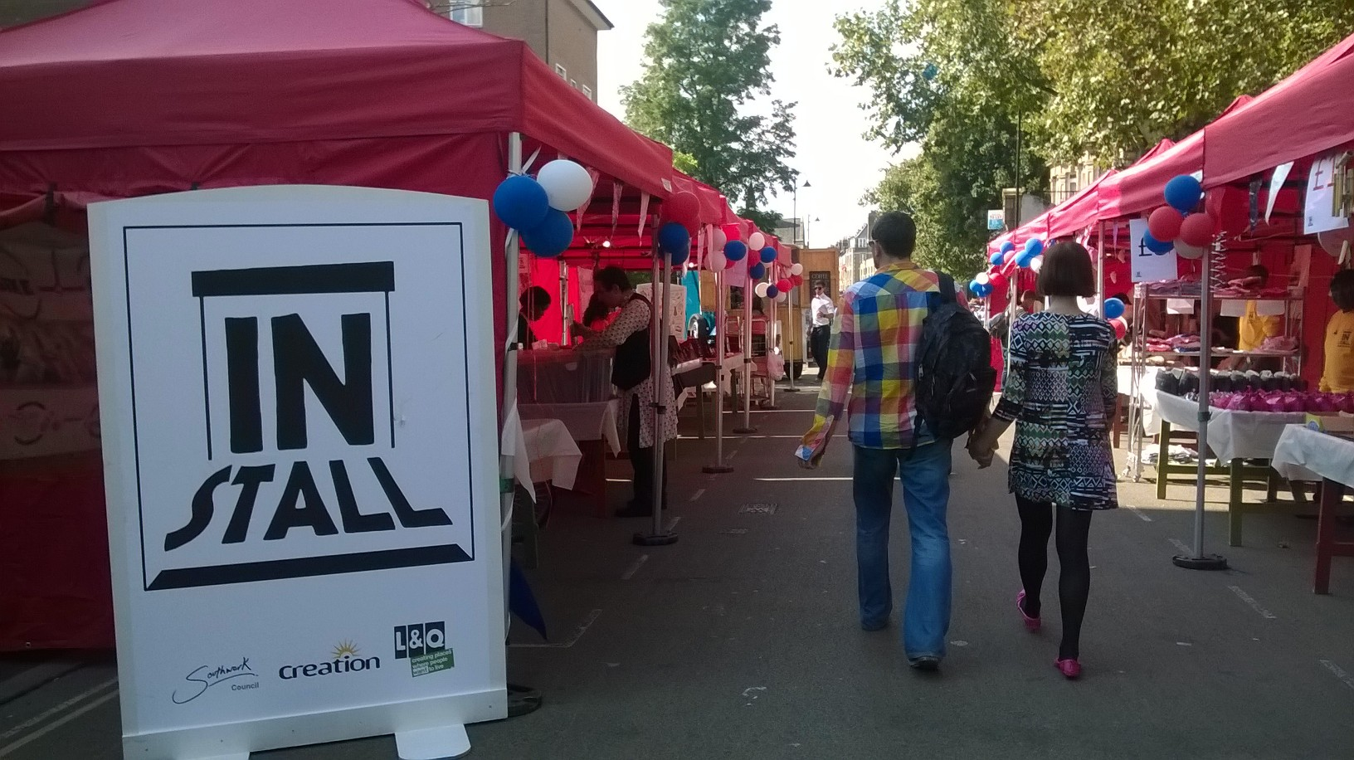

This type of project was quite different to the main employability projects as it involved working with businesses from outside of the borough.

by

Proposal: Deliver 1 skills based project

Proposal

Total

Item of Expenditure | Budget (in UK £ Sterling)
Project Co-ordinator & Project Manager | 5827.17
Stationery | 500
Telephone | 200.00
Market Stall Setup | 4211.94
Marketing | 360.00
Travel | 100.65
Training Room | 398.00
Subsistence | 420.50
Total | 12018.26

Aylesbury Apprentice
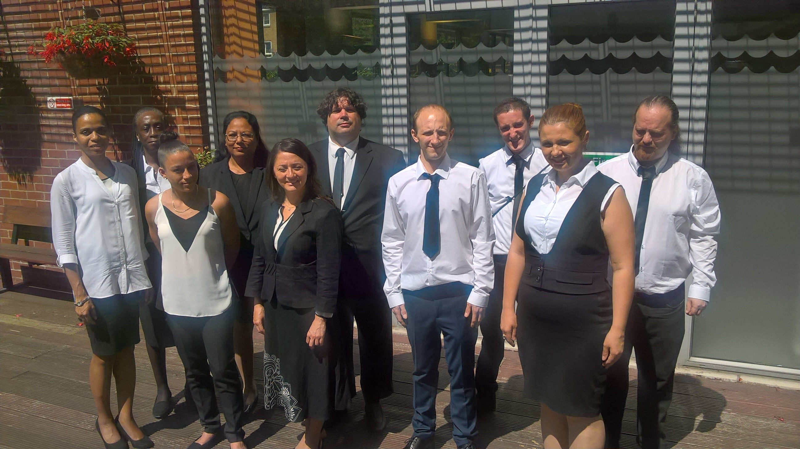

Although this type of project established a conversion rate of 50%, as it was funded through the DWP it is highly unlikely that we could afford to continue delivering projects of this nature given the new DWP procurement process.

4.14 The DWP Flexible Support Fund (FSF) Aylesbury Apprentice ran from 29th February to 10th October 2016 and was delivered by a Project Co-ordinator and Assistant. L&Q funds went towards incentives and extra services which were not covered through the DWP funding. The project outcomes were to work with 50 clients and obtain 25 jobs. Clients could also obtain a NCFE qualification in demonstrating Enterprise Skills. 6 clients obtained a Level 1 award, and 11 Level 2. 25 of these clients went into employment within 13 weeks.

4.15 The 6 tasks which were undertaken through this project were as follows:
Arts Gallery; refurbish a disused space into an Arts Gallery with an installation for viewing within 2 weeks
Lunch Box; Prepare and package a healthy lunch time snack accompanied with dips and water to be sold at East Street Market
Unisex Clothes Stall; Visit rag trade distributors; source clothing to design a theme to be sold as a package to both male and female shoppers
Bespoke Toy; Identify, source, manufacture and package a ‘Children’s Toy’
Comedy Club; Research, Promote and produce a comedy show for an audience of up to 30 people to be put on at Artworks
Fritters: Create a hot “Fritters” dish to be sold at East Street Market

The Arts Gallery challenge was featured as an article in the South London Press.

Item of Expenditure | Budget (in UK £ Sterling)
Project Co-ordinator | 41.5hrs x £17.50 = 23,240
Enterprise and Customer Service specialists Training | 320 x 2 x 4 x 2 = 2560
Guest/Motivational Speaker sessions | 521 x 6 = 3126
NCFE Demonstrating Enterprise Skills (50 Candidates) | 50 x 60 = 3000
Projects Stock | 1875 x 2 = 3750
Marketing and Task Set up | 1563 x 2 = 3126
Training Room Hire | 125 x 15 x 2 = 3750
Beneficiary costs, Subsistence, Travel, Awards | 50 x 37.50 = 1875
Phones | 500
Total | 44,927

Vlogging
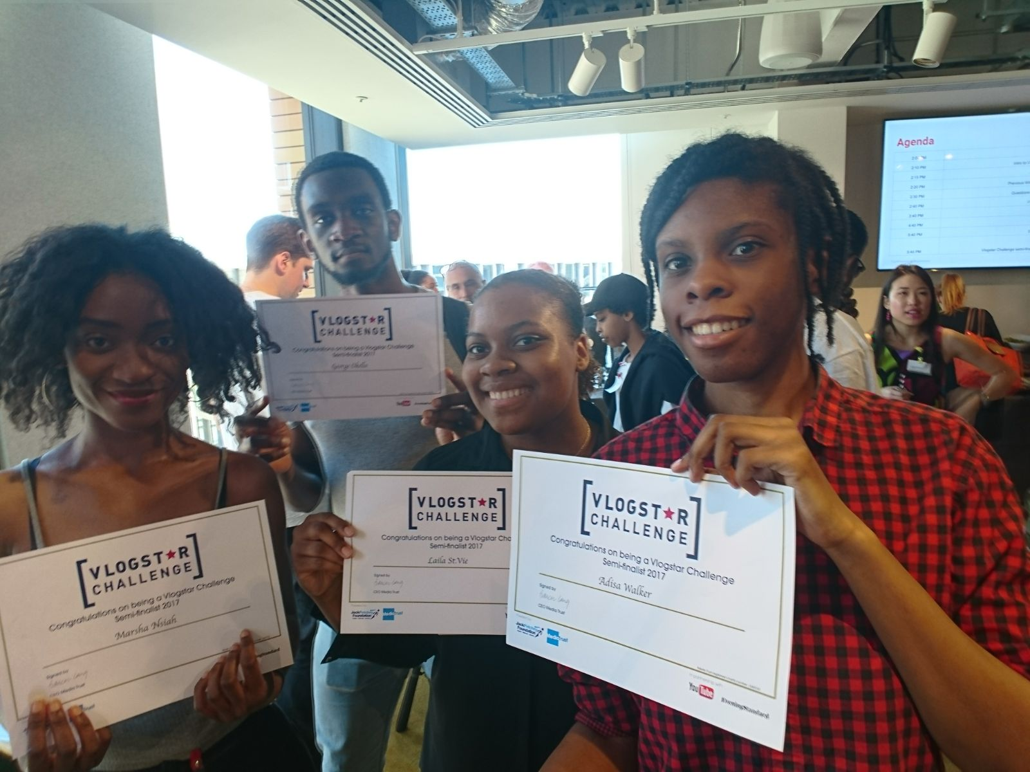

4.16 In November 2016 and March 2017 we held two Vlogging workshops in collaboration with Media Citizens/Youtube where over 26 young people attended. The main aim of the workshop was to train young people how to use Vlogging equipment vlog, with those that were able to show the most creativity and skills entered into a national competition with the prize being £500 worth of equipment and one to one sessions with YouTube Specialist Staff/Contributors.

4.17 Out of 1500 entrants, 150 young people were selected to go forward to the semi- finals where only 15 would go on to the finals. Of the 150 selected 4 were SE17Working clients, with one of the same going through to the finals. The success of these workshops inspired SE17Working to apply for funding towards a themed Vlogging Project through Southwark Council’s High Street Challenge. The project aimed to promote the diversity of 8 Southwark Highstreets; showcase 10 businesses in each and then upload the vlogs to YouTube.

4.18 The funding supported a series of workshops where young people were taught how to use Vlogging equipment, and how to interview local businesses/residents. Clients aged 16-24 could also receive a Qualification through the Arts Council Funded “Arts Awards”, of which 5 participants are currently undertaking. The final result saw 10 high Streets covered and 102 businesses promoted. A private screening was held on February 6th 2017 at Shortwave Café where some of the business promoted were able to see coverage of their businesses for the first time.

FUNDED PROJECTS

5.1 SE17Working commissioned three organisations to support people into employment by identifying and removing barriers as follows:
- Lone Parents
- ESA/IB Claimants; People with Mental Health Issues
- Over 25’s

5.2 The projects were funded to run until March 2013 with a further 3 months for tracking. They were funded through SE17 Working grants of £75000, being part of the overall L&Q Added Value award to Creation Trust.

5.3 Kaleidoscope - £39,463
Kaleidoscope ran an exciting project to support lone parents into sustainable employment. They provided opportunities available including part time and term time jobs in:

- Retail
- Childcare
- Hospitality
- Administration
- Care

6 week programme offer:

- CV build and preparation
- Career advice and guidance
- One to one Job brokerage and support
- Confidence building workshops
- Guaranteed interviews and work placements

Expected Outcome | Expected Outputs
Starts | 40
Employment | 17
Volunteering/Further Training | 20
Actual Outcome | Actual Outputs
Starts | 32
Work Experience | 1
CV and Interview Skills | 32
Employment | 7
Volunteering/Further Training | 12

5.4 Cambridge House - £10,900
Through the Cambridge House project, clients on ESA/IB allowances or those with mental health issues could expect:
- 8 weeks (up to 12 hours p/w) individualised training & support with their own ‘mentor’ who you will meet weekly
- A personalised Action Plan to break down steps to finding a job
- Professional advice about CV writing, interview and application skills
- An up to date, professional, CV
- ‘Real’ work experience at a place of their choice
- Lunch and refreshments
- Confidence & Support
- Introduction, information & referral to other support agencies based at Cambridge House (including Blackfriars Advice Centre and Cambridge House Law and Advocacy services)

Expected Outcome | Expected Outputs
Starts | 12
Work Experience | 10
CV and Interview Skills | 10
Employment | 4
Volunteering/Further Training | 4
Actual Outcome | Actual Outputs
Starts | 17
Work Experience | 4
CV and Interview Skills | 10
Employment | 1
Volunteering/Further Training | 6
Other | 1

5.5 Robust Training - £24,637
Robust Training assisted unemployed clients over 25 years old who had an interest in working in the following Industries:

- Transport
- Construction
- Security
- Health and Social Care
- Retail

They provided free 6 and 8 weeks courses for residents to obtain the following awards:
- TPH Licence
- CSCS card
- SIA Badges
- Certificates in retail
- Certificates in Health and Social Care

Expected Outcome | Expected Outputs
Starts | 100
Work Experience | 90
Employment | 51
Actual Outcome | Actual Outputs
Starts | 32
Volunteering/Further Training | 32

5.6 Over the course of the project 66 referrals were made by Creation Trust. During monitoring visits it was soon established that although the organisation was engaging with SE17 clients they were not able to determine which clients were eligible for the project ie. Aylesbury Estate and L&Q SE17 residents.

5.7 It was eventually determined that they had only engaged with 24 clients of the 66 referred. The SE17Working Board decided that at this stage it would be requesting a clawback amount from Robust of £9967.00 from the £14782 already received, leaving them £4815 to complete the courses for the 24 clients. In the interim Creation had identified issues with SIA badge purchases for residents and due to this had to become an SIA Company Sponsor in order to process SIA badge Applications directly.

5.8 3X3 Funding

The 3 x 3 Funding was a small-grants programme that aspired to spend monies left over from the main SE17Working Project Grants once all project spend had been accounted for. Again, local organisations that could demonstrate that their services were of benefirt to residents were invited to submit applications up to £3000.

5.9 Inspire £3000
InSpire proposed to develop a high quality and innovative online CV and employability resource for SE17 residents. This included one 5-10 minute employability video, one 5-10 minute CV writing podcast, and an accompanying handbook that could be downloaded and used simultaneously. The project offered a comprehensive and creative guide to producing CV’s and candidates of a high standard, by utilizing the skills in employability, podcasts and filming of our existing staff team. The final product was uploaded to the SE17Working site, until its removal in 2017 for more updated information.

5.10 Certitude £11,000
Southside Partnership was commissioned to engage with 19 unemployed individuals whom suffer from common mental illnesses (depression or anxiety or both) or suspected to be, and who seek to get back into work, with 10 going into employment. 85% of all residents engaged in the programme would also l report improved mental health, more confidence in coping with changes, and more independence, less isolation. These outcomes were reduced to 10 Aylesbury Estate residents with 5 job Outcomes. The project cost was £11,000.

5.11 Although the targets were achieved, it was not without issues many in terms of the Project Advisor being absent for most of the project for most of the duration. The outcomes were achieved by SE17Working providing risk management by way of assisting clients with finding employment.

Expected Outcome | Expected Outputs
Starts | 15
Employment | 5
Sustainability | 3
Actual Outcome | Actual Outputs
Starts | 10
Employment | 5
Sustainability | 3

5.12 Elm House Training £29,000
Whilst sourcing employment for clients it was apparent that local Nurseries were finding it difficult to appoint Nursery Assistants at level 2 or above, mainly due to literacy and numeracy issues at initial assessment.

5.13 The course started on Wednesday 17th May 2017, and is located at The Giraffe House. 30 clients applied for the course – which included an initial assessment using our Fast Track literacy and numeracy test. Out of the 30 only 9 passed the assessment. These 9 went on for a test with Elm House Training of which 8 enrolled on the course. The placements, with 1st Place Children and Parent’ Centre, started in August 2017 and will continue until the end of the course in July 2018.

5.14 The funding is for 10 clients to obtain an NVQ Level 3/4 Certificate in Childcare and find local work placements whilst on training. It is aimed towards longer term employment and better employment options for families with young children as the working hours fit well with access to childcare.



Since 2012, SE17Working has awarded funds to local providers to add value to the Programme. However, there is some risk involved in terms of acquiring outcomes and although projects are fully monitored, any underperformance is often draining on Creation resources and therefore, as a small organisation, not sustainable.

Proposal:

Proposal:

Total

TARGETED DELIVERY
Construction
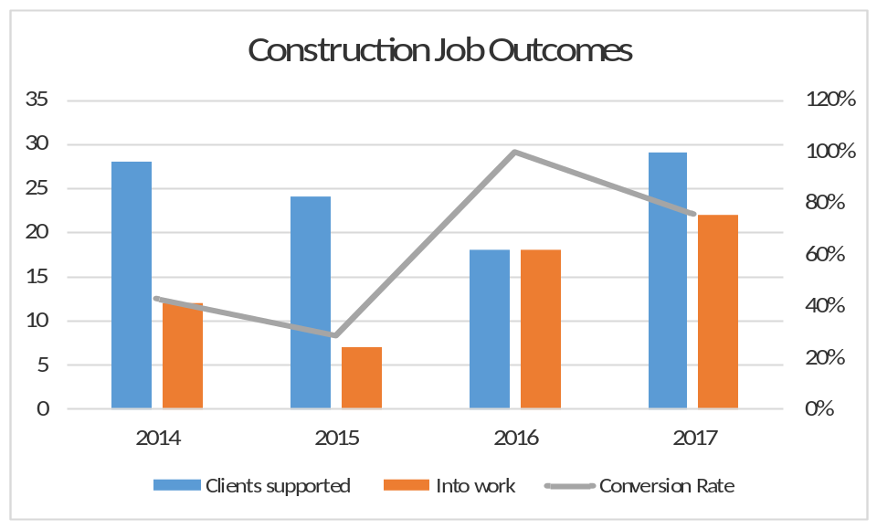

Year | Clients supported | Into work | Conversion Rate
2014 | 28 | 12 | 43%
2015 | 24 | 7 | 29%
2016 | 18 | 18 | 100%
2017 | 29 | 22 | 76%
Total | 99 | 59 | 59%

6.1 Since 2016, SE17Working has supported 40 clients into construction roles. Over the years we have seen a huge conversion rate of clients supported in looking for working in construction to those securing work in this industry.

  - SE17Working has worked in partnership with by working in close partnership with development projects in the community including Lendlease and Erith Demolition. The success in finding clients employment is due to the fact that we have seen a significant rise in Construction related salaries. At the start of 2016, general labourers were commonly receiving the basic national minimum wage (£7.50). However, towards the end of 2017 salaries it was more common to find that they were receiving wages of more than £9.00. This may be due to developers now recognising the value of the London Living Wage (£9.50/hour) or there is simply a higher demand for labourers as development sites grow across the city.

6.3 Lendlease delivers regular recruitment drives to support local people into work. The SE17Working Team continues to maintain a good relationship and regular communicates regularly regarding client referrals and new vacancies, Erith Demolition had also worked closely with SE17Working as a Notting Hill Genesis supplier, and most recently 4 clients were supported into employment during the demolition on the First development site.

6.4 Case Study: Saidu registered with SE17Working after being out of work for 6 months. 3 days after registering with SE17Working he found work with an agency. Before he took up this opportunity, he was referred to Lendlease where he successful at his interview. Whilst waiting for his start date with Lendlease he had the opportunity to earn money with the agency, making the transition from agency to a permanent contract near enough seamless. Saidu has now been working for Lendlease for 9 months.

6.5 Michael Smith had been working in construction for 20 years as a site manager. He had been made redundant 3 months before coming to SE17Working for support. Although Michael had a valid CSCS card, he had lost confidence because of his previous redundancy. Michael was supported by attending a number of workshops including Confidence and Motivation; Skills Profiling and Job Goals; and Interview Skills. He was also supported in applying for a permanent position where he also could receive demolition training. Michael is now working for Keltbray.

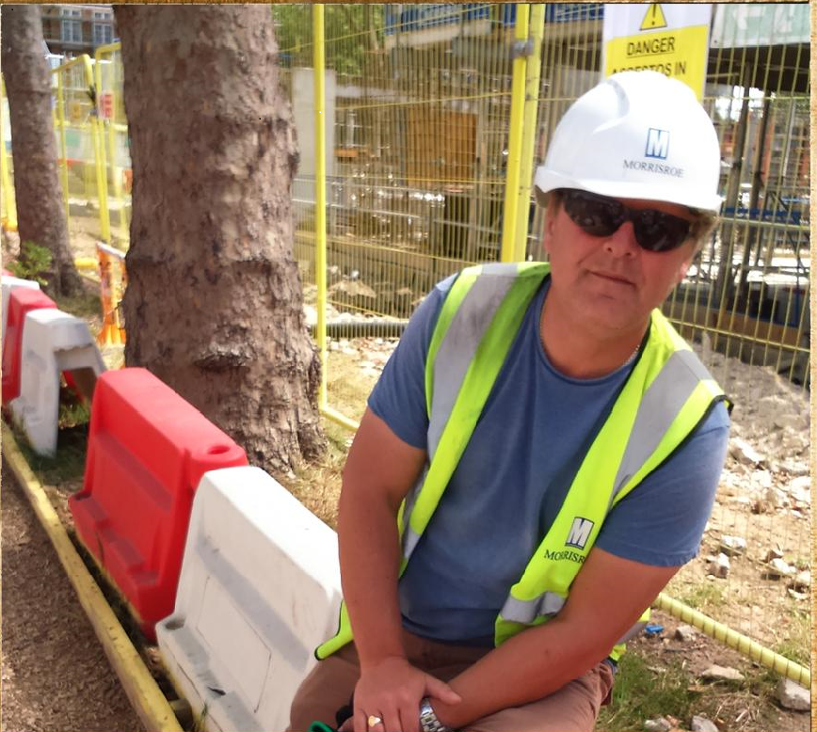

SE17Working has focused on Construction since 2012. Whilst there have been a delay in relation to accessing construction jobs on Aylesbury Estate sites, we have forged an excellent relationship with developers with a steady flow of vacancies that have benefit ted residents. Currently Notting Hill Genesis provide training and funds for CSCS cards which enables SE17Working funds to be applied to other project work.

Proposal:

Total

ESOL
6.6 There are more than 20 languages spoken at Michael Faraday Primary School which borders the estate and therefore reflective of the diversity of the area. Often when trying to communicate, residents have difficulty understanding the information advice and/or guidance given or are unable to communicate their enquiry well. In addition, when sourcing jobs, employers are more frequently requesting that applicants both write and speak English at least at basic and conversational level.

6.7 SE17Working has provided ESOL classes since 2013, which 52 people attended over the life of the project. In 2017 there were 14 clients taking ESOL classes. 10 of these went on to acquire a Trinity ESOL qualification. The ESOL classes ceased in December 2017.

6.8 Although we understand that there is ongoing need, there are other local organisations that are now providing ESOL including 1st Place Childrens’ and Parents Centre which is literally 500 yards from where the SE17Working ESOL classes were being held, and Southwark Adult Education Centre which is on the Peckham side of Burgess Park. Former SE17Working ESOL clients, and new, have been referred to these organisations.


6.9 In addition to English language needs by ESOL, clients have been identified that have little to no reading and writing skills even though they have been through UK education system. To this end Creation Trust has been successful in acquiring funds from the Awards for All Funding Programme for a schools based adult basic literacy project “English breakfast” which will be of benefit to both clients with basic literacy needs and ESOL clients.

There is an ongoing need to assist residents with basic literacy and numeracy skills as well as supporting those who may need to further improve ESOL

Total

OUTCOMES
7.1 Since 2015 to 2018 we have secured 696 Jobs, with a conversion rate of 53%. 40% of these residents had participated in one or more of our training programmes with the remainder finding employment through one-to-one job search.

Outcomes 2015 – 2018

 | All | BME | 50+ | LP | PWD | Women | Low Skill | Aylesbury | under 25
No. unemployed Southwark residents supported | 1301 | 1086 | 295 | 228 | 114 | 731 | 446 | 572 | 260
No. receiving training | 279 | 213 | 50 | 55 | 32 | 127 | 82 | 130 | 70
No. entering employment | 696 | 507 | 144 | 92 | 53 | 386 | 205 | 247 | 136
Conversion Rate into unemployment | 53% | 46% | 48% | 40% | 46% | 52% | 45% | 43% | 52%

7.2 The conversion rates for people going to employment against all clients supported is on average 53%. The highest conversion rate is of female clients (52%), followed by under 25’s (52%) and clients who are over 50 years old (48%).

7.3 These groups might be more open minded to entry level jobs, of which there are a high number in London, due to the following;

- women - working hours that fit around their children
- under 25’s - predominantly be looking for entry level work due to age
- over 50’s - fear of having to reskill or fear of age discrimination.

As the roles that appeal to 25–50 year olds are typically professional or management, there could be lower staff turnover in these roles meaning less opportunities for clients to apply for these jobs. The conversion rate for lone parents sits at the lowest (40%). This may be due to the lack of accessible childcare for children under the age of 3.

Barriers to employment

7.4 SE17Working strives to put people forward for jobs that pay the London Living Wage, however the labour market within central London and the immediate surrounding area still has a high number of vacancies that pay the minimum wage, or just above minimum wage. These jobs are generally available because of high staff turnover (cleaning, construction, care). This has seen people looking for work decline positions.

7.5 Unfortunately depression, and the culture attached to the same, is a common occurrence for those who are unemployed. Residents who are long term unemployed may not feel they are capable of going back to work and therefore sabotage opportunities to work by:
- not turning up to interviews/appointments
- saying things to deter interviewers despite interview guidance from SE17Working
- not presenting themselves professionally at interviews
- not turning up for their first day of work.

7.6 Some clients whom are long term unemployed have unrealistic views as to the roles they can go into. Some feel that they can go back into a discipline of work they have been in previously, which may now requires them to have updated skills which they have not obtained as they have been out of work in that field for several years. SE17Working has worked with clients who, for example, wish to go into administrative positions but possess limited IT skills meaning they cannot fulfil the requirements of the position.

7.7 Lack of IT, literacy, and numeracy skills pose a threat to clients being able to apply for entry level roles. Computer and internet access is also a problem. Clients can book computer use in local libraries and a few local providers, however this is subject to availability and normally have a time limit attached. SE17Working’s conversion rate for people who are deemed as Low Skilled is 45%, compared to those with disabilities at 48%. This latter rate could be due to a rise in the “two tick” scheme where employers reserve roles for people with registered disabilities. It has been found that some clients whom have poor literacy and numeracy skills and/or dyslexia may have not declared the same as a disability having not been professionally diagnosed.

7.8 SE17Working has facilitated a wide range of training workshops and short courses to help clients overcome their barriers into work which include Confidence building and Motivation; Skills Profiling and Job Goals; Interview Skills; Money Management and Weight Watchers. These workshops have proven to boost the confidence of clients and prepare them to return to work.

7.9 Case Study: Marco was referred to SE17Working by the job centre as part of the Aylesbury Apprentice Project - a bespoke project to help people with employability skills, incorporating innovative team challenges. Marco had been out of employment for 5 years after being made redundant from his role as a car park attendant. He had several barriers that prevented him from going to work and was long term unemployed after working in his prior position for 12 years. He required support with his confidence; presentation skills; job searching and was not familiar with articulating himself in a professional environment. He was initially supported in finding a temporary position working as an attendant for Hilton Hotels, however now he has found a permanent position working as a groundsman with Quadron/ID Verde.

THE FUTURE
8.1 SE17Working was created to fulfil Creation Trusts 4 key activity areas, namely:

Delivering youth programmes to increase educational attainment, improve well-being and reduce anti-social behaviour

Supporting vulnerable residents who are isolated and at risk with a focus on depression and anxiety for all ages & advocating for them

Delivering services for adults to improve their skills, economic opportunities and well-being

Providing residents with opportunities and information to encourage them to participate in their local community

We have consistently focused and worked within these areas, and believe that the proposed future projects will continue to do so.

8.2 The L&Q funding element of the Programme has now ended. It has been agreed by the Board that SE17Working Programme continue to support tackling unemployment on the estate and neighbouring streets.

There is an estimated £55,000 for employment projects with the retention of 2 FTE staff members.

8.3 Creation recognises the need to ensure it is working closely with local partners and the opportunities that the redevelopment will provide through the supply chain, including apprenticeships, which will come through partnership working with Notting Hill Genesis. Work and Training opportunities will continue to be promoted through the SE17Working website and Echo, and resources will be shared to collaborate on employability programme delivery going forward.

Proposed delivery 2017 - 2018

8.4 Job Search and bespoke one to one Support will be retained. This activity will be co-ordinated by the SE17Working Employment Advisor, with a target of 60 job outcomes per annum.

8.5 Short courses is a key element of the SE17Working Programme. Attendance continues to be high with clients moving on to further training and employment. Courses are designed to PTTLS/DTTLS standards which played a role in the success of the Fast track to Employment; Work Out Well! (WOW); STAR; Confidence and Motivation; Job Goals and Skills Profiling workshops/courses.

8.6 With Funding from the Big Lottery Fund Awards for All Programme, the ‘English Breakfast’ Project will be delivered aimed at parents in local schools and those whom need to develop their language skills, to help with an identified literacy and numeracy skills gap.

8.7 Following on from the success of Skilled it! and the Vlogging project, employment skills based training for young people aged 16-25 will be delivered over the year, incorporating Arts Awards accreditation where possible as Creation Trust is now registered as an Arts Awards Assessment Centre.

8.8 The Giraffe House has proven to be an asset as a Training centre attracting bookings from DWP contractors/subcontractors including Pecan, Go train, and Aim Apprenticeships. We will assist these training providers, and more, with recruiting local people onto courses held here, and support the same with job search on course completion.

8.9 Working with Southwark Young advisors and other local youth providers, we will explore how to engage and support the hardest to reach young people aged 16 and under, and those at risk, with a regular evening activity based at the Giraffe House. Working with this age group is paramount in developing the future stability of the area, therefore resources will be invested into ensuring small local providers have skilled and qualified staff available at all times when delivering services for this age group.

8.10 In collaboration with the School of Social Entrepreneurs, and following on from the success of the Pop up Shop and Aylesbury Apprentice, sessions will be delivered to develop business ideas and explore the development of interim use of spaces for local interest and benefit.

FINANCIAL HIGHLIGHTS
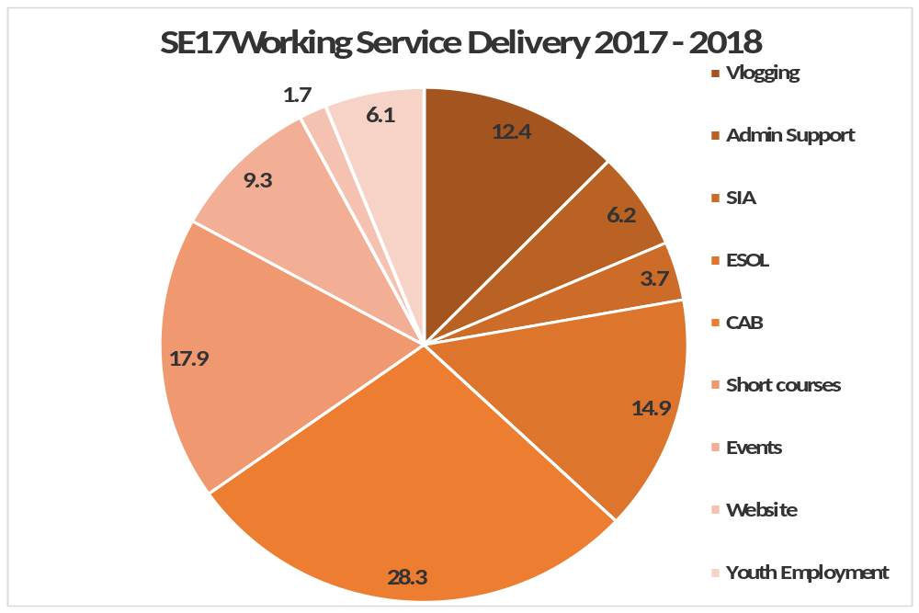

Service Delivery Financial Breakdown
Vlogging | £7,279
Funded through Southwark High Street Challenge
Admin Support | £3,630
Includes Building overheads
SIA | £2,139
Courses provided through Training Circle
ESOL | £8,745
More than 50% of funds towards Tutor Costs
CAB | £16,612
Drop in session with an Advisor Each Tuesday x 50 weeks
Short courses | £10,479
External Tutors and Lunches/Client incentives
Events | £5,438
Celebrating Achievement and Client Reward Vouchers
Website | £985
Used in Job Search Sessions for residents and through NHHT
Youth Employment | £3,553
Equipment Hire for external event; lunches and incentives
Total | £58,860
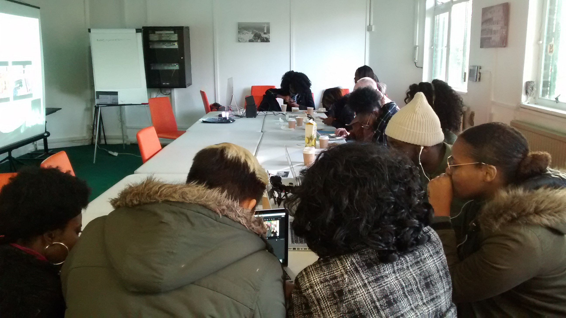

For further information on the contents of this Report please contact:
Patrischia Warmington
Director - SE17Working
Email patrischia@creationtrust.org
Tel: 0207 703 8923


info@creationtrust.org
www.creationtrust.org
www.se17Working.co.uk
Twitter: @CreationSE17

